Let Computer Recognize Your Face

Deep Learning for Industrial Applications

Member:M10703426 Min-Hsiang Chang, M10703435 Hung-Yi Wu

1. Introduction

The development of science has made human life more convenient. Delivering heavy and monotonous work to the computer can focus on more meaningful places.Face recognition is an important part in the surveillance system and is related to the accuracy of the system.

1. Method
2. Face Detection

Using the SSD-512 method and VGG-16 as the architecture, the RGB images lens is used as input to automatically detect the face area.

1. Facial landmark and alignment

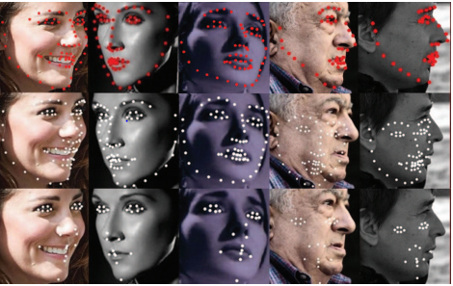

1. Face Recognition

We intend to use Resnet-50 as the network architecture, training database for CASIA, Multi-PIE or other larger face database. By using different loss functions and testing on the CFP database, we expect to achieve an accuracy of more than 85% of the face.

1. Project details

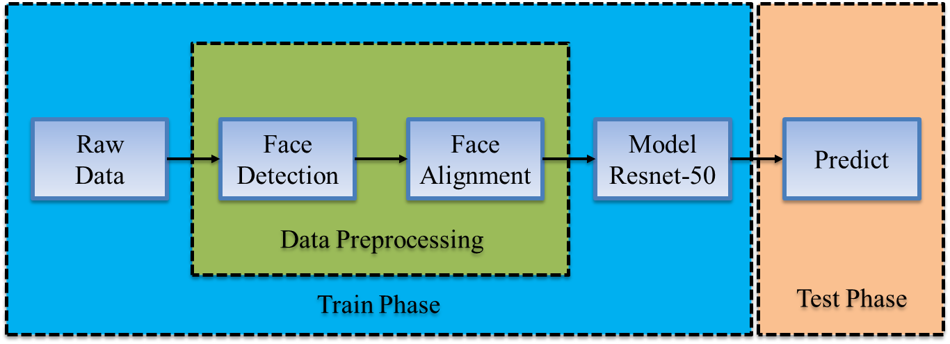

1. Training Data

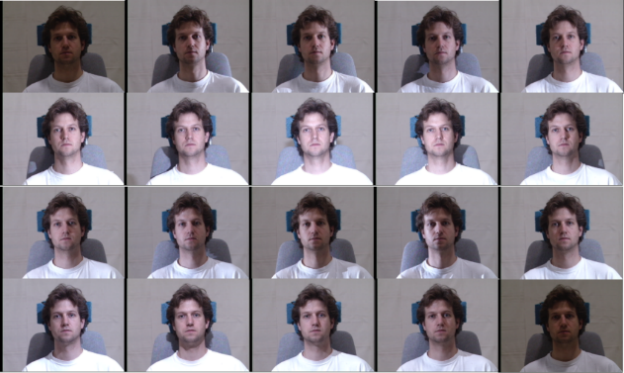

Multi-PIE Database

1. In the house, taken through Session 1~4, Se. {249, 203, 230, 239}

2. 337 subjects with more than 750k images

19 illuminations, 5 expressions, 15 poses

188 subjects for training

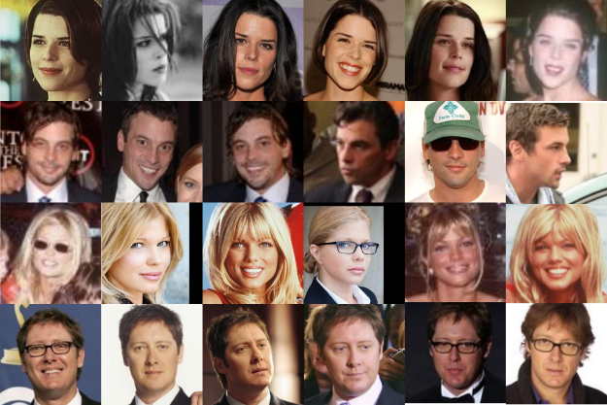

CASIA-WebFace Database

1. Unconstrained environment

2. 10,575 identities with 494,414 images

3. Collected from Internet Movie

Database (IMDB)

4. Large training data in public

1. Issue:

Data imbalance:

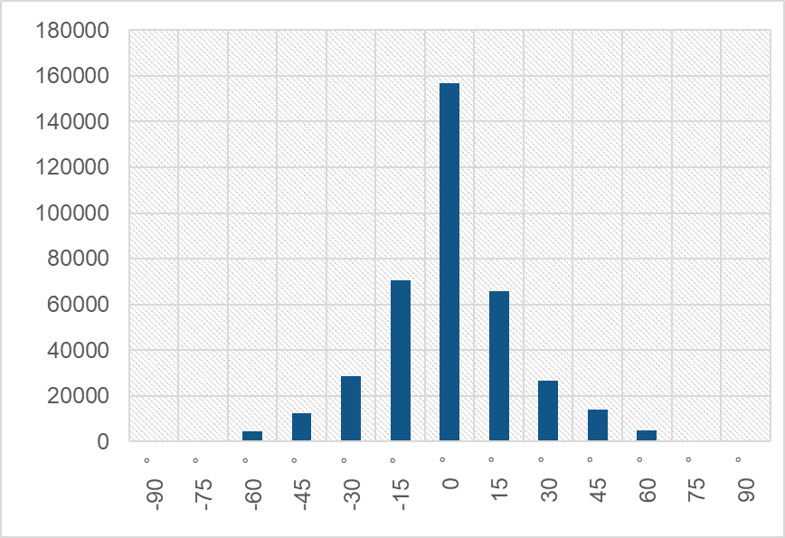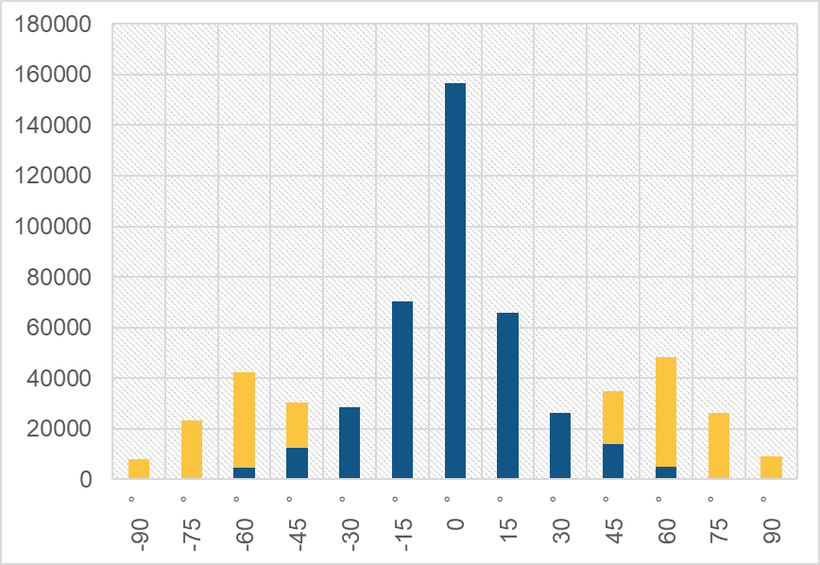

1.The chart on the left is the distribution of our training data set, we can find that most of the data is concentrated between -15 and 15 degrees. Therefore, this will cause the model to only recognize facial images of small pose.

2.The chart on the right is the distribution of our training data set after data augmentation.We try to increase the facial images of large pose and let the model discriminate the facial images of large pose.

1. Improve

Data augmentation method: **3D Morphable Model (3DMM)**

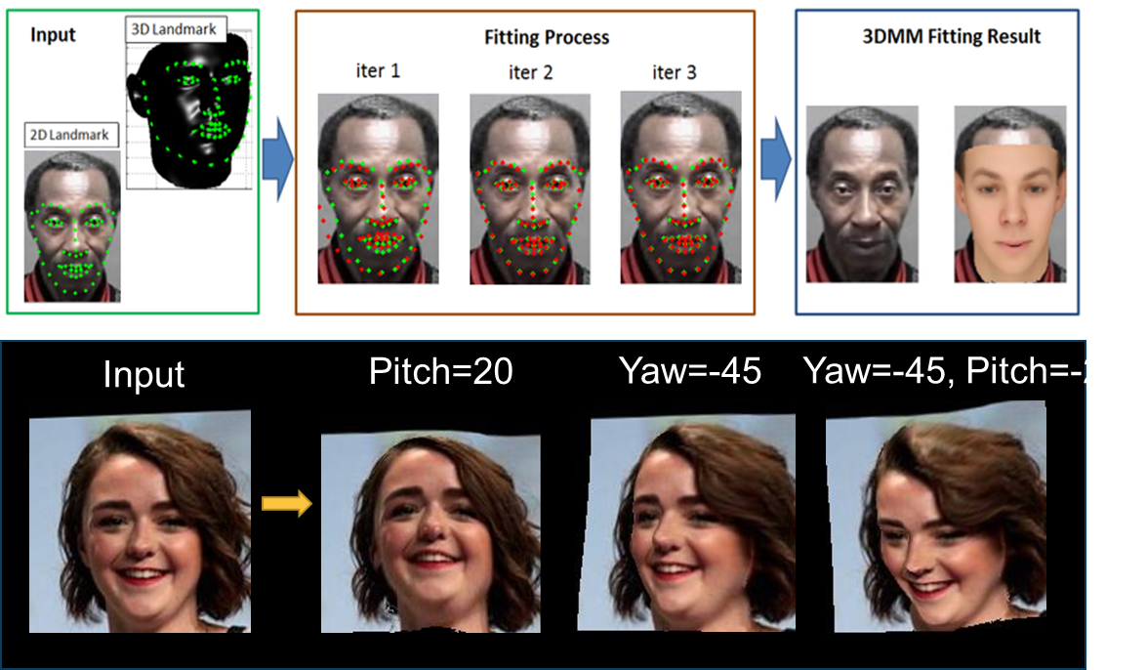

Data augmentation result :

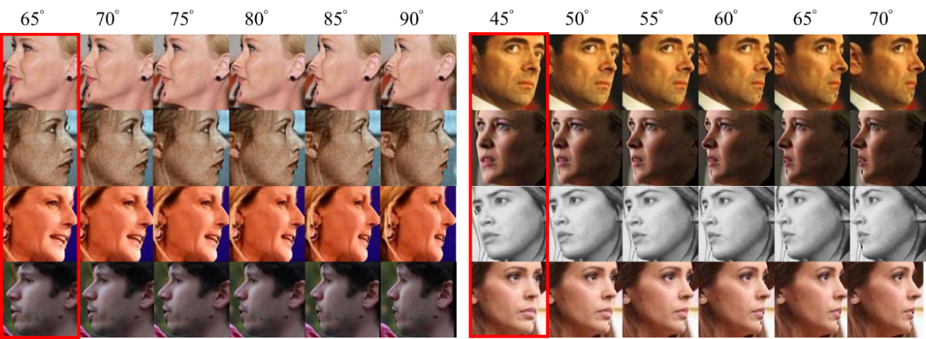

The images in the red box are input images.

1. Test data and method

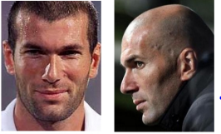

Celebrities in Frontal-Profile Database:

1. CFP contains 10 frontal and 4 profile images of 500 individuals.

2. We have defined 10 splits, each containing 350 same and 350 not-same pairs. The task is for face verification

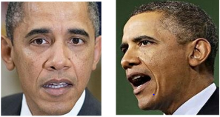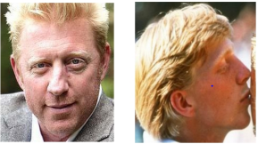

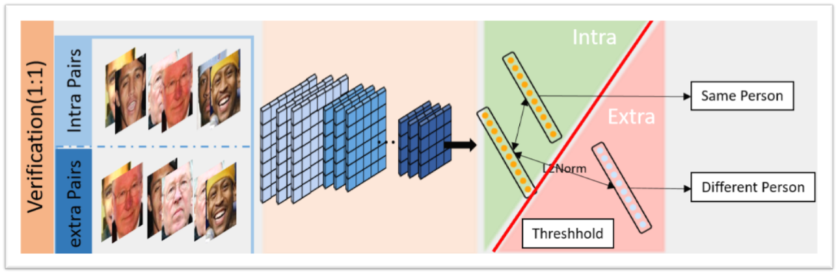

1. Result and Analysis

Result (CFP_ori)

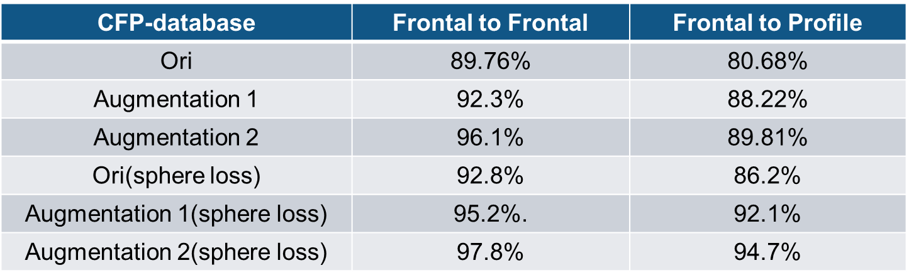

Result (CFP with our data)

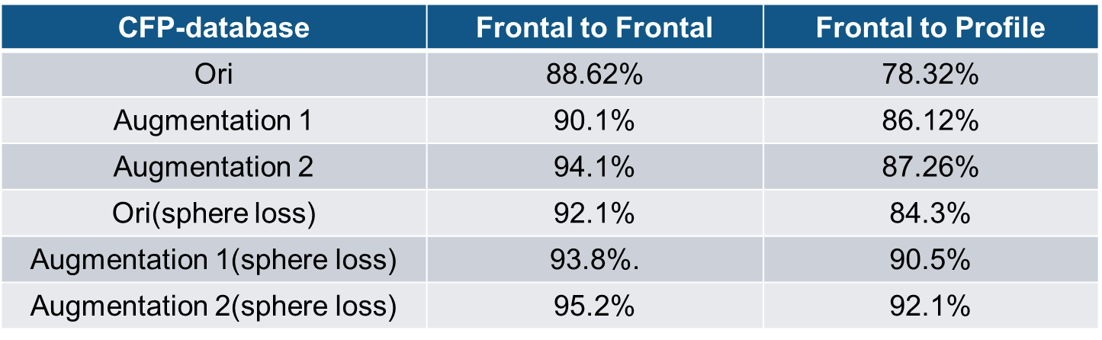

Result Analysis:

From the above table, we can find that the accuracy of the test is reduced after adding our own image to the test database.

The analysis results show that when the test data is the face of a Westerner, the model can distinguish the distance between two faces very well, but when the test data is the Oriental face (we), the model cannot accurately distinguish it.

The reason for this result is that the training data we used did not have many images of the faces of the Orientals, making the model unable to discriminate the faces of the Orientals.

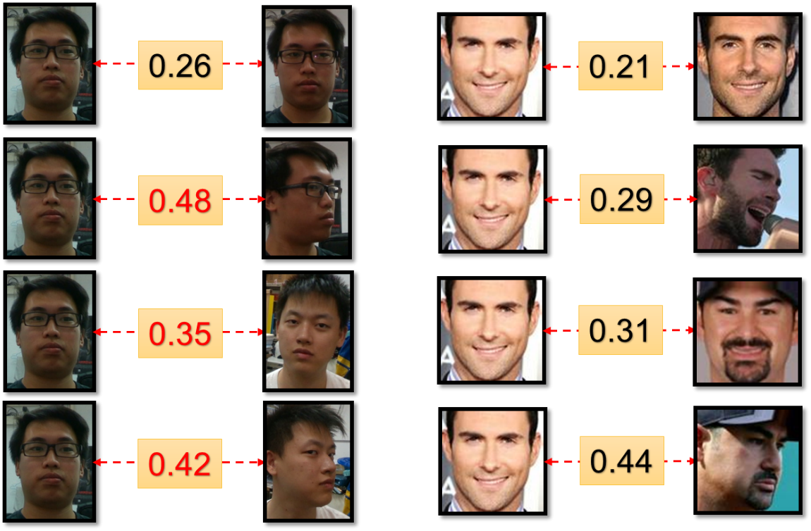

Euclidean Distance

1. Conclusion

Data:

* Data augmentation can solve the data imbalance problem and improve our model.
* Training database will decide the domain of the feature.

Loss:

* The better loss function can get the discriminative feature.

1. Reference

G.-S. Hsu and C.-H. Hsieh, “Multi-Dropout Regression for Wide-Angle Landmark Localization,” ICIP 2017, Beijing

K. Simonyan and A. Zisserman, “Very Deep Convolutional Networks For Large-Scale Image Recognition,” ICLR 2015

W. Liu, D. Anguelov, D. Erhan, C. Szegedy, S. Reed, C.-Y. Fu and A.-C. Berg, “SSD: Single Shot MultiBox Detector,” ECCV2016

Kaiming He, Xiangyu Zhang, Shaoqing Ren and Jian Sun.” Deep Residual Learning for Image Recognition” CVPR2015

[Hao Wang](https://arxiv.org/search/cs?searchtype=author&query=Wang%2C+H), [Yitong Wang](https://arxiv.org/search/cs?searchtype=author&query=Wang%2C+Y), [Zheng Zhou](https://arxiv.org/search/cs?searchtype=author&query=Zhou%2C+Z), [Xing Ji](https://arxiv.org/search/cs?searchtype=author&query=Ji%2C+X), [Dihong Gong](https://arxiv.org/search/cs?searchtype=author&query=Gong%2C+D), [Jingchao Zhou](https://arxiv.org/search/cs?searchtype=author&query=Zhou%2C+J), [Zhifeng Li](https://arxiv.org/search/cs?searchtype=author&query=Li%2C+Z) and [Wei Liu](https://arxiv.org/search/cs?searchtype=author&query=Liu%2C+W),,” CosFace: Large Margin Cosine Loss for Deep Face Recognition” CVPR2018

Yandong Wen, Kaipeng Zhang, Zhifeng Li and Yu Qiao,” A Discriminative Feature Learning Approach for Deep Face Recognition” ECCV2016